APPENDIX A
PHOTOGRAPHS TAKEN DURING JIV AT 18” OBAMA-BRASS PIPELINE AT GOLUBOKIRI COMMUNITY, NEMBE L.G.A, BAYELSA STATE ON 30TH MARCH, 2024.
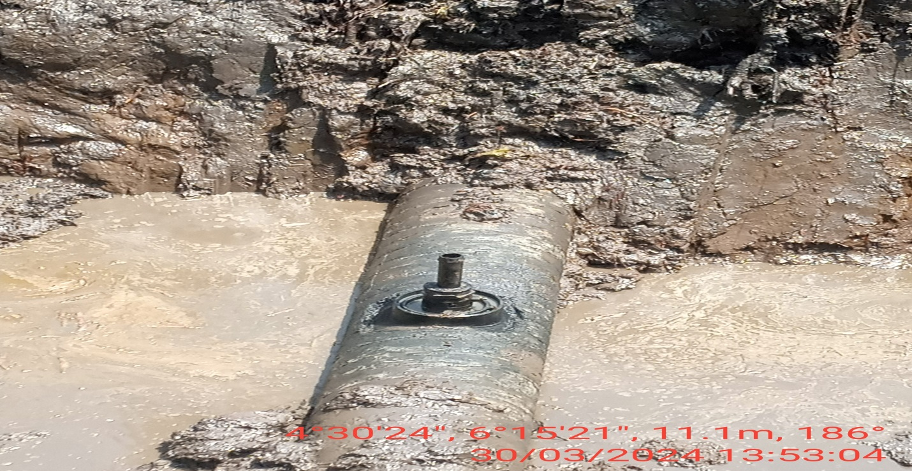
Fig. 1: 2” valve installed at 12 O’ clock position of the pipeline by Vandals.
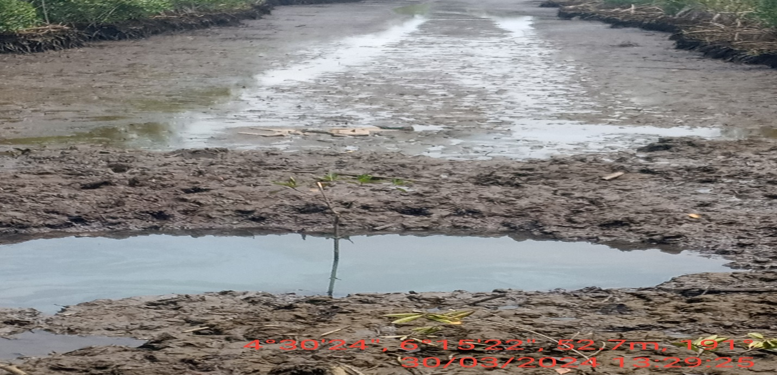
Fig. 2: The state of the environment as at the time of JIV.

